How to use LISTAGG in PSQuery – S1

Requisition | S1
Check the last 2 Fields  Last field has been marked as DUMMY as these fields make up the LISTAGG function and idea is to aggregate on these columns | 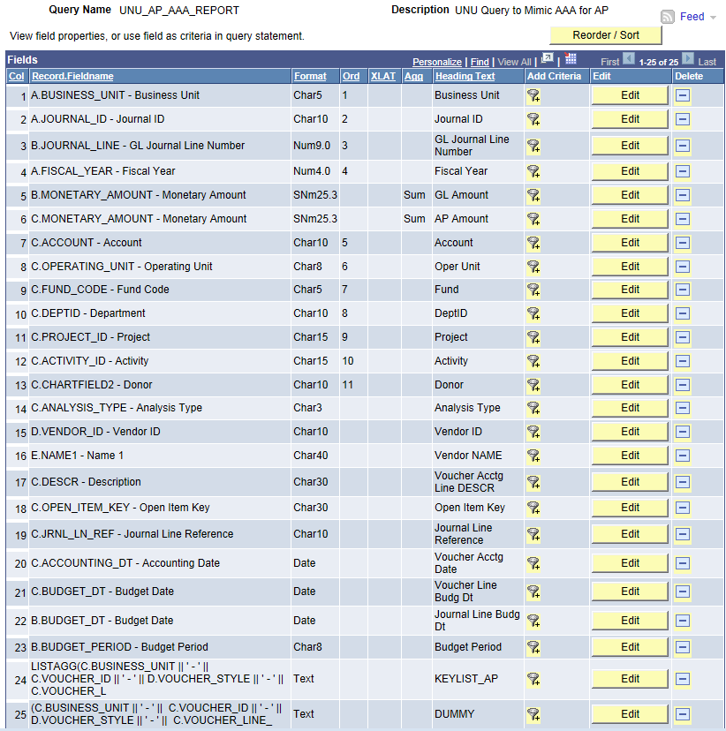
Custom Expressions have to be added to accommodate the LISTAGG Oracle Function  For the Expression which has LISTAGG, make sure to check the checkbox “Aggregate Function”  For the second Expression (which contains the concatenation of columns being aggregated by the LISTAGG function), DO NOT check the checkbox “Aggregate Function”  Once done, select aggregate function on the AMOUNT fields that you would want to roll-up | 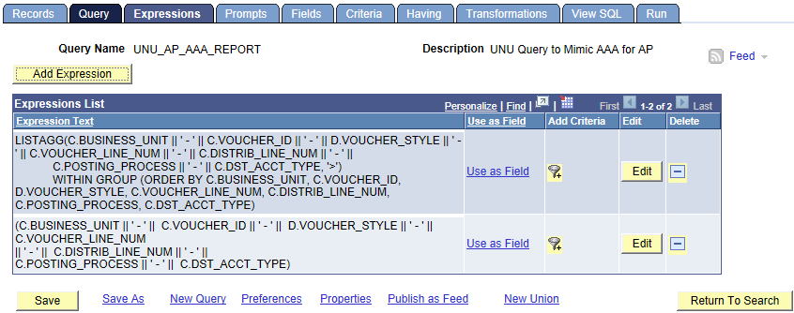  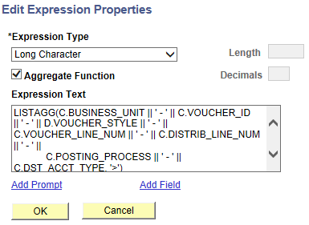  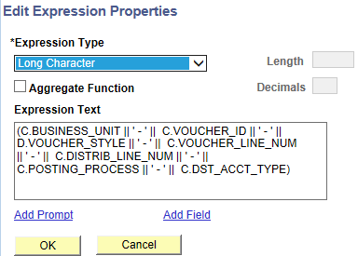
SQL looks like | 